**EXPERIMENT -8**

**EXP NO 8:** CREATE A VIRTUAL MACHINE WITH 1 CPU, 2GB RAM AND 15GB STORAGE DISK USING A TYPE 2 VIRTUALIZATION SOFTWARE.

**DATE: 03/10/25**

**AIM:** To create a virtual machine with 1 cpu, 2gb ram and 15gb storage disk using a type 2 virtualization software.

**PROCEDURE:**

STEP 1: Download VMware workstation and installed as type 2 hypervisor.

STEP2: Download ubuntu or tiny OS as iso image file.

STEP 3: In VMware workstation->create new VM.

STEP 4: Do the basic configuration settings.

STEP 5: Created tiny OS virtual machine.

STEP 6: Launch the VM.

**IMPLEMENTATION:**

Step 1: Download VM ware Workstation and Installed as Type 2 Hypervisor

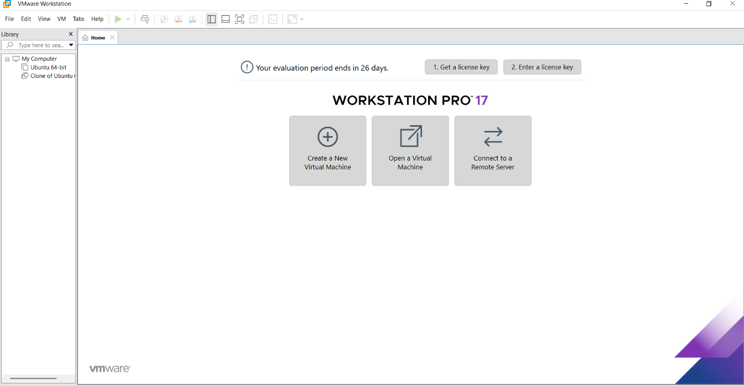

Step 2: In VMware Workstation->Create New VM



Step 3: Do The Basic Configuration Settings.

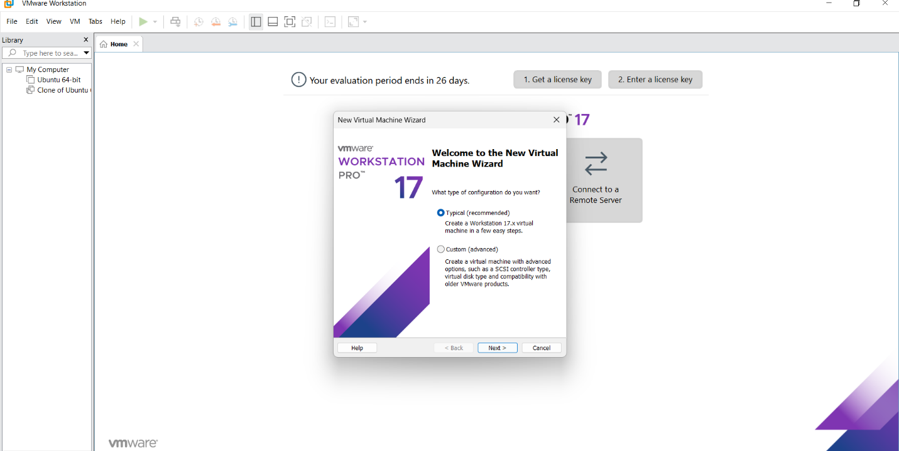

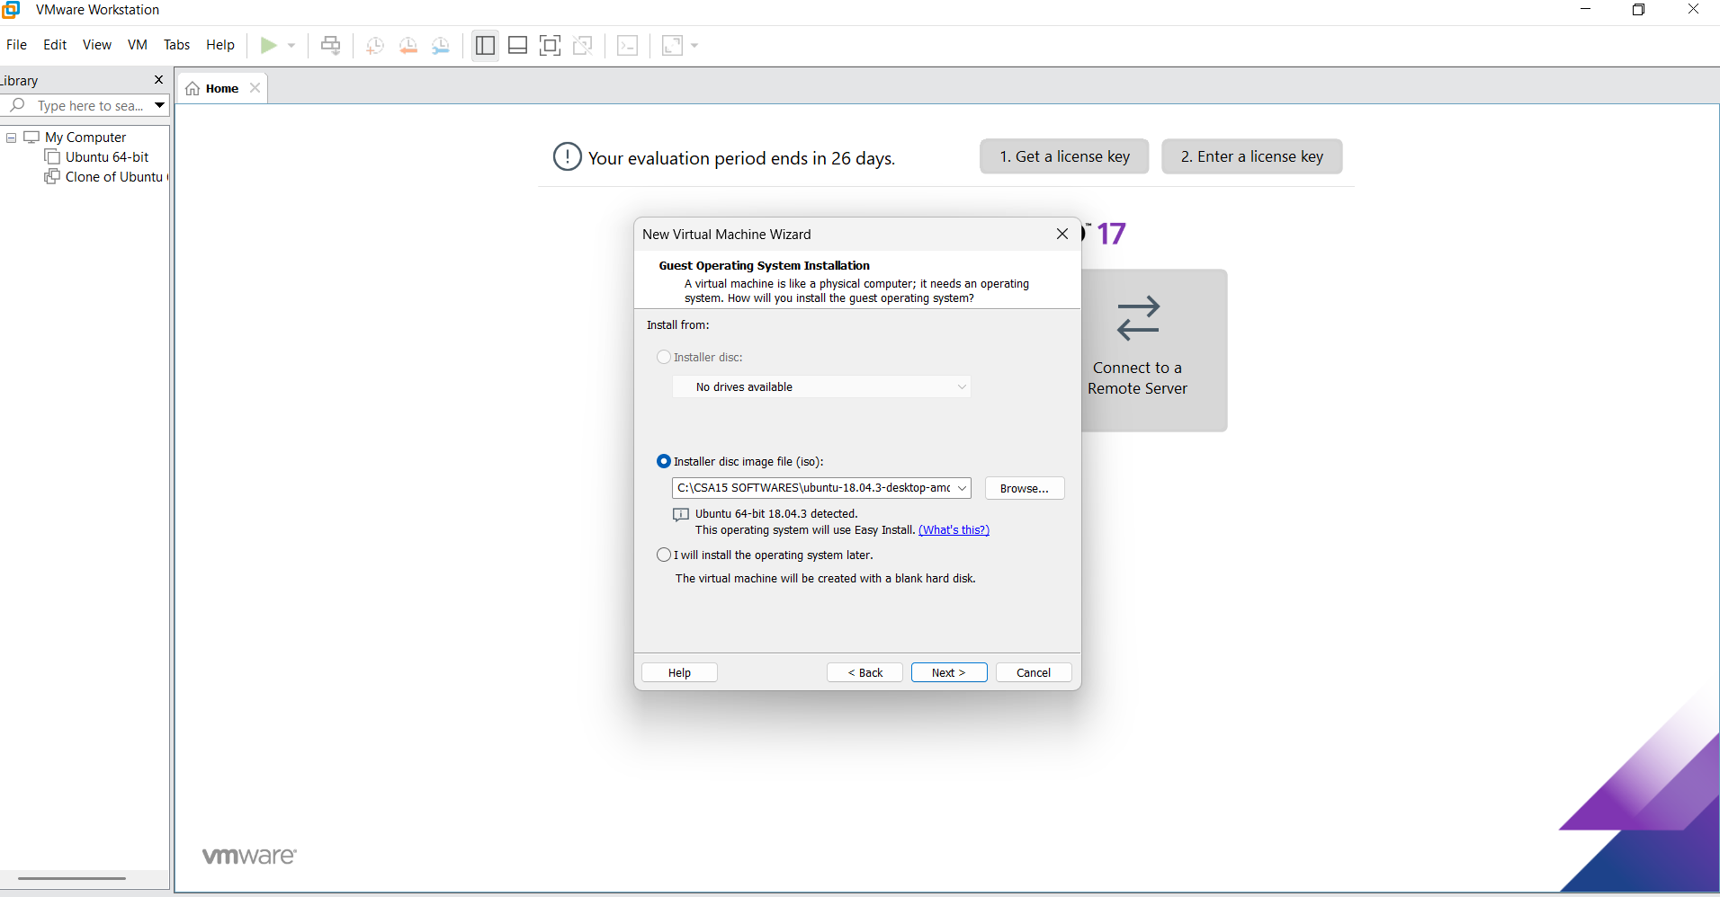

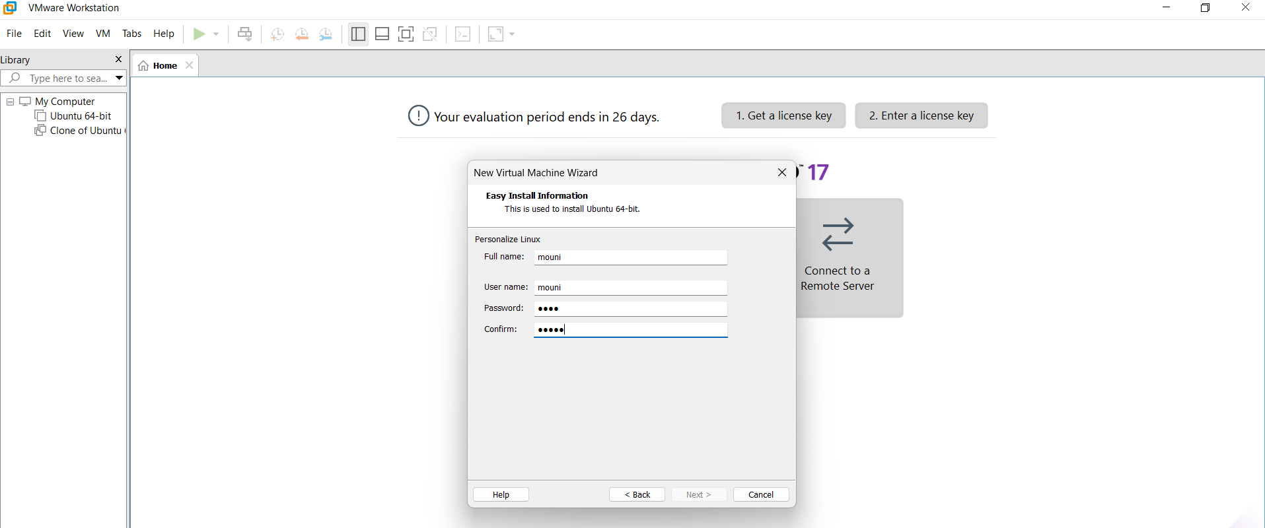

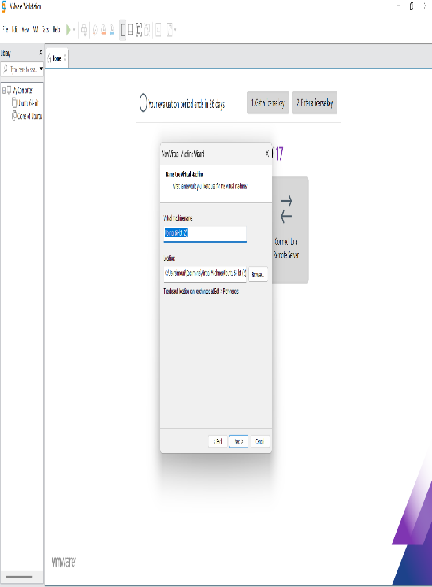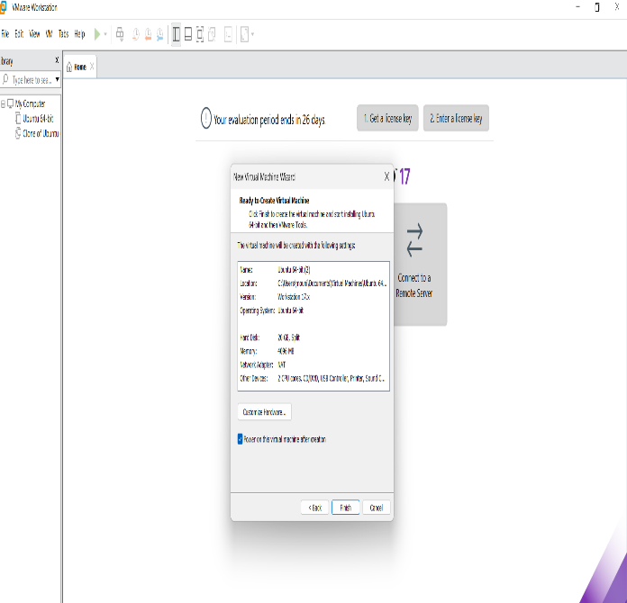

Step 4: Created Tinyos Virtual Machine

